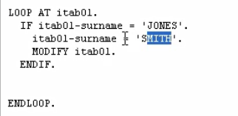

So, if the if statement is true, we then have the modify statement. Which will take the contents of the headline that we have just updated and update the record in the internal table that was originally read into the head record.

Now, the modify statement has some specific features when used inside the loop for an internal table. So, in our case, modify statement only changes the contents of the existing line in the internal table that we have read. It does not create a brand-new record.

If the modify statement is in a loop, it is always the current line that is changed. But please note, you should not do this if you are trying to modify key fields of an internal table that use a unique key. If the modified statement is used outside of a loop, we must specify the record index number that we want to modify, because we have got no index number being monitored by the system automatically like when we have our code inside a loop.

Now a little note is the way we use the modify statements in our example here, we can only it this way with index tables and tables with header lines.